SIGN-IN AND IN-COMING REPORT

TENANT: Sylvie Faith Kerr-Smith

PROPERT: 5/103 Tunstall Ave KINGSFORD 2032 NSW

The tenant(s) listed above acknowledge receipt of the Ingoing Condition Report dated upon pick up of room keys.

Please complete the required in as much detail as possible & return to our office within 7 days of receipt to be given a photocopy.

It is important that you complete this sufficiently and return to us as this report shows how the property was given to you. At the time of vacating, our office and/or landlord will complete an exit condition report (bond inspection) that will compare with the ingoing condition report.

If you have any further questions or require any assistance in relation to this matter, please do not hesitate to contact your Property Manager.

Collected by Tenant(s) Agent Acknowledgement

On, date:

Tenant(s) Name:

Tenant(s) Signature:

On, date:

Agent Name& Initial(s):

KEY SHEET

TENANT
PROPERTY:
Sylvie Faith Kerr Smith
5/103 Tunstall Ave KINGSFORD 2032 NSW

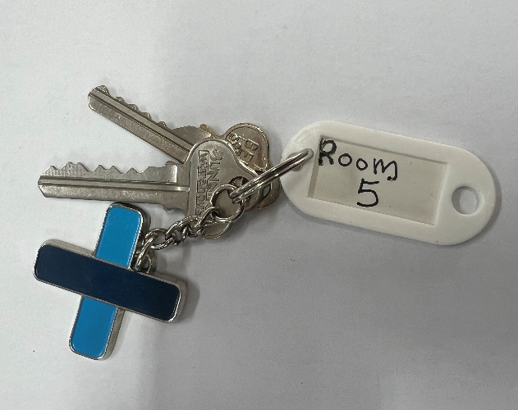

Number of keys (2):
- All remote & keys (including copies) must be returned to the agent’s office upon vacating the property.
- The tenant(s) is not to change the key/locks without first obtaining approval from the agent.
- Any tenant(s) that lose/misplace their key must pay for the cost of producing a copy from our office (if available) or, tenant(s) must pay for the cost of changing locks/key and producing a spare set of keys.
- The tenant(s) must notify agent if any furnishings are damaged.
- The tenant(s) must seek approval from the agent if any furnishings are altered or removed

Tenant(S) Name and Signature: …………………………………………….

Date: ……………………………………

DOCUMENT SHEET
Tenant acknowledges receipt of the following documents and keys from the Agent prior to or on the date of starting the occupancy lease:

Document | Initial
- Copy of the Residential Tenancy Agreement (fully executed)
- Property condition report, to be completed and returned within 7 days of the signing the lease (PAGES )
- # of Keys ( ) Garage/Gate Remote/s
- Internet Found on Modem
- BSB & Account Details
- New House Rules
- Rubbish Removal Roster Acknowledgement and Attached

Security Door/Garage/Parking/Alarm Details and Other topics to be recorded:

Tenant(s) Name and Signature: …………………………………………..

Date: …………………………………………..

Agents/ Owner’s Signature: …………………………………………

IN-COMING INSPECTION
Tenant acknowledges the record of the condition of the premises on the date of date of starting the occupancy lease:

Feature | Initial
- The tenant has had a chance to inspect the residential room and premises, in the presence of the agent or owner prior to occupancy
- The tenant agrees that the residential room is structurally sound, clean, undamaged and fit for purpose
- The tenant agrees that the premises, common areas and amenities are clean, undamaged and fit for purpose
- The tenant has tested the keys to the premises and the room and confirmed that they are functional
- The tenant has reviewed and completed the furniture list
- An Internet Line is Connected to the Premises and Sign in is Complete
- The Internet Usage is not separately recorded by residential room.
- The residential rooms are not separately metered and water meets water efficiency requirements (see below)
- The tenant agrees there are no signs of mould and dampness
- The tenant agrees there are no signs of pests or vermin
- The tenant agrees there is no rubbish left in the occupant’s room, or in or around the premises.
- The tenant agrees with the agent’s assessment of the premises (pages 5-10)
- The tenant has notified the agent or owner of any concerns

The tenant must return one copy of the completed condition report to the landlord or landlord’s agent within 7 days after receiving it and is to keep the second copy.

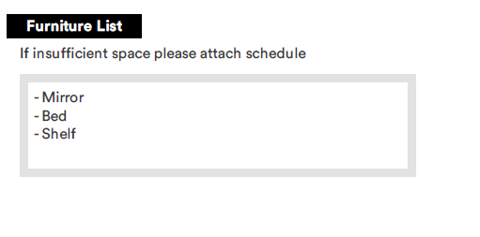


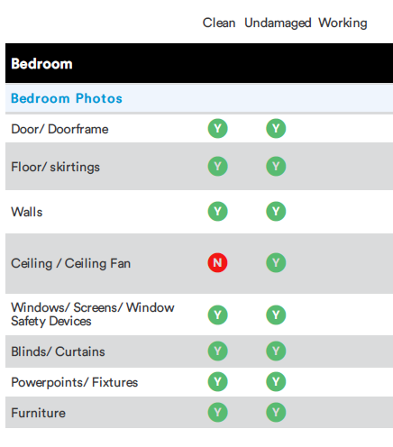

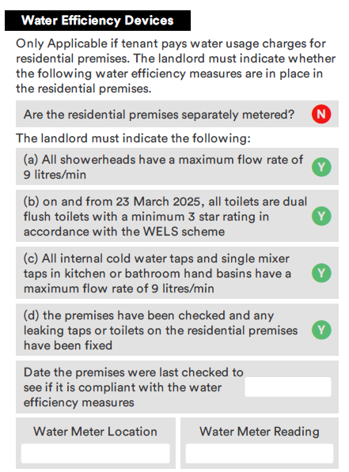

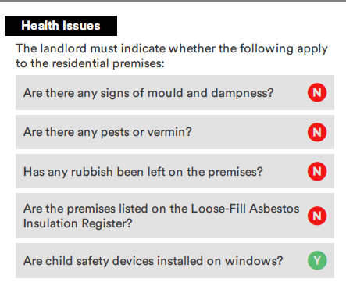
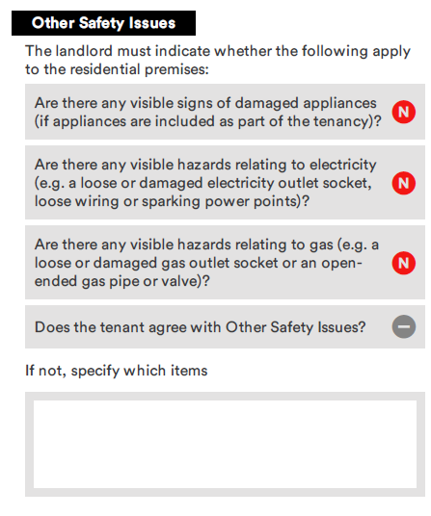
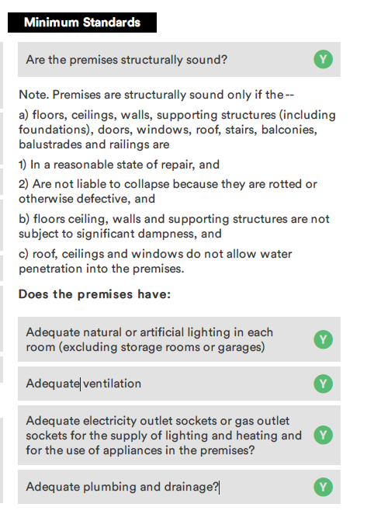
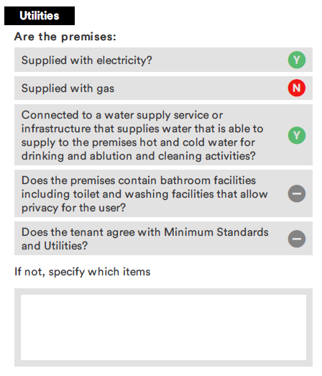
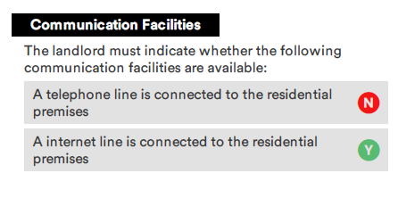
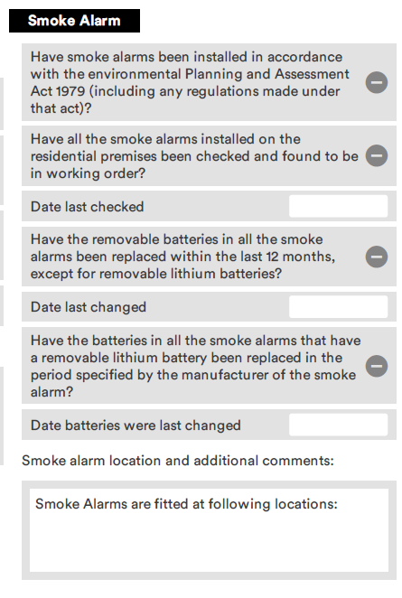

IN-COMING REPORT PICTURES OF ROOM #

